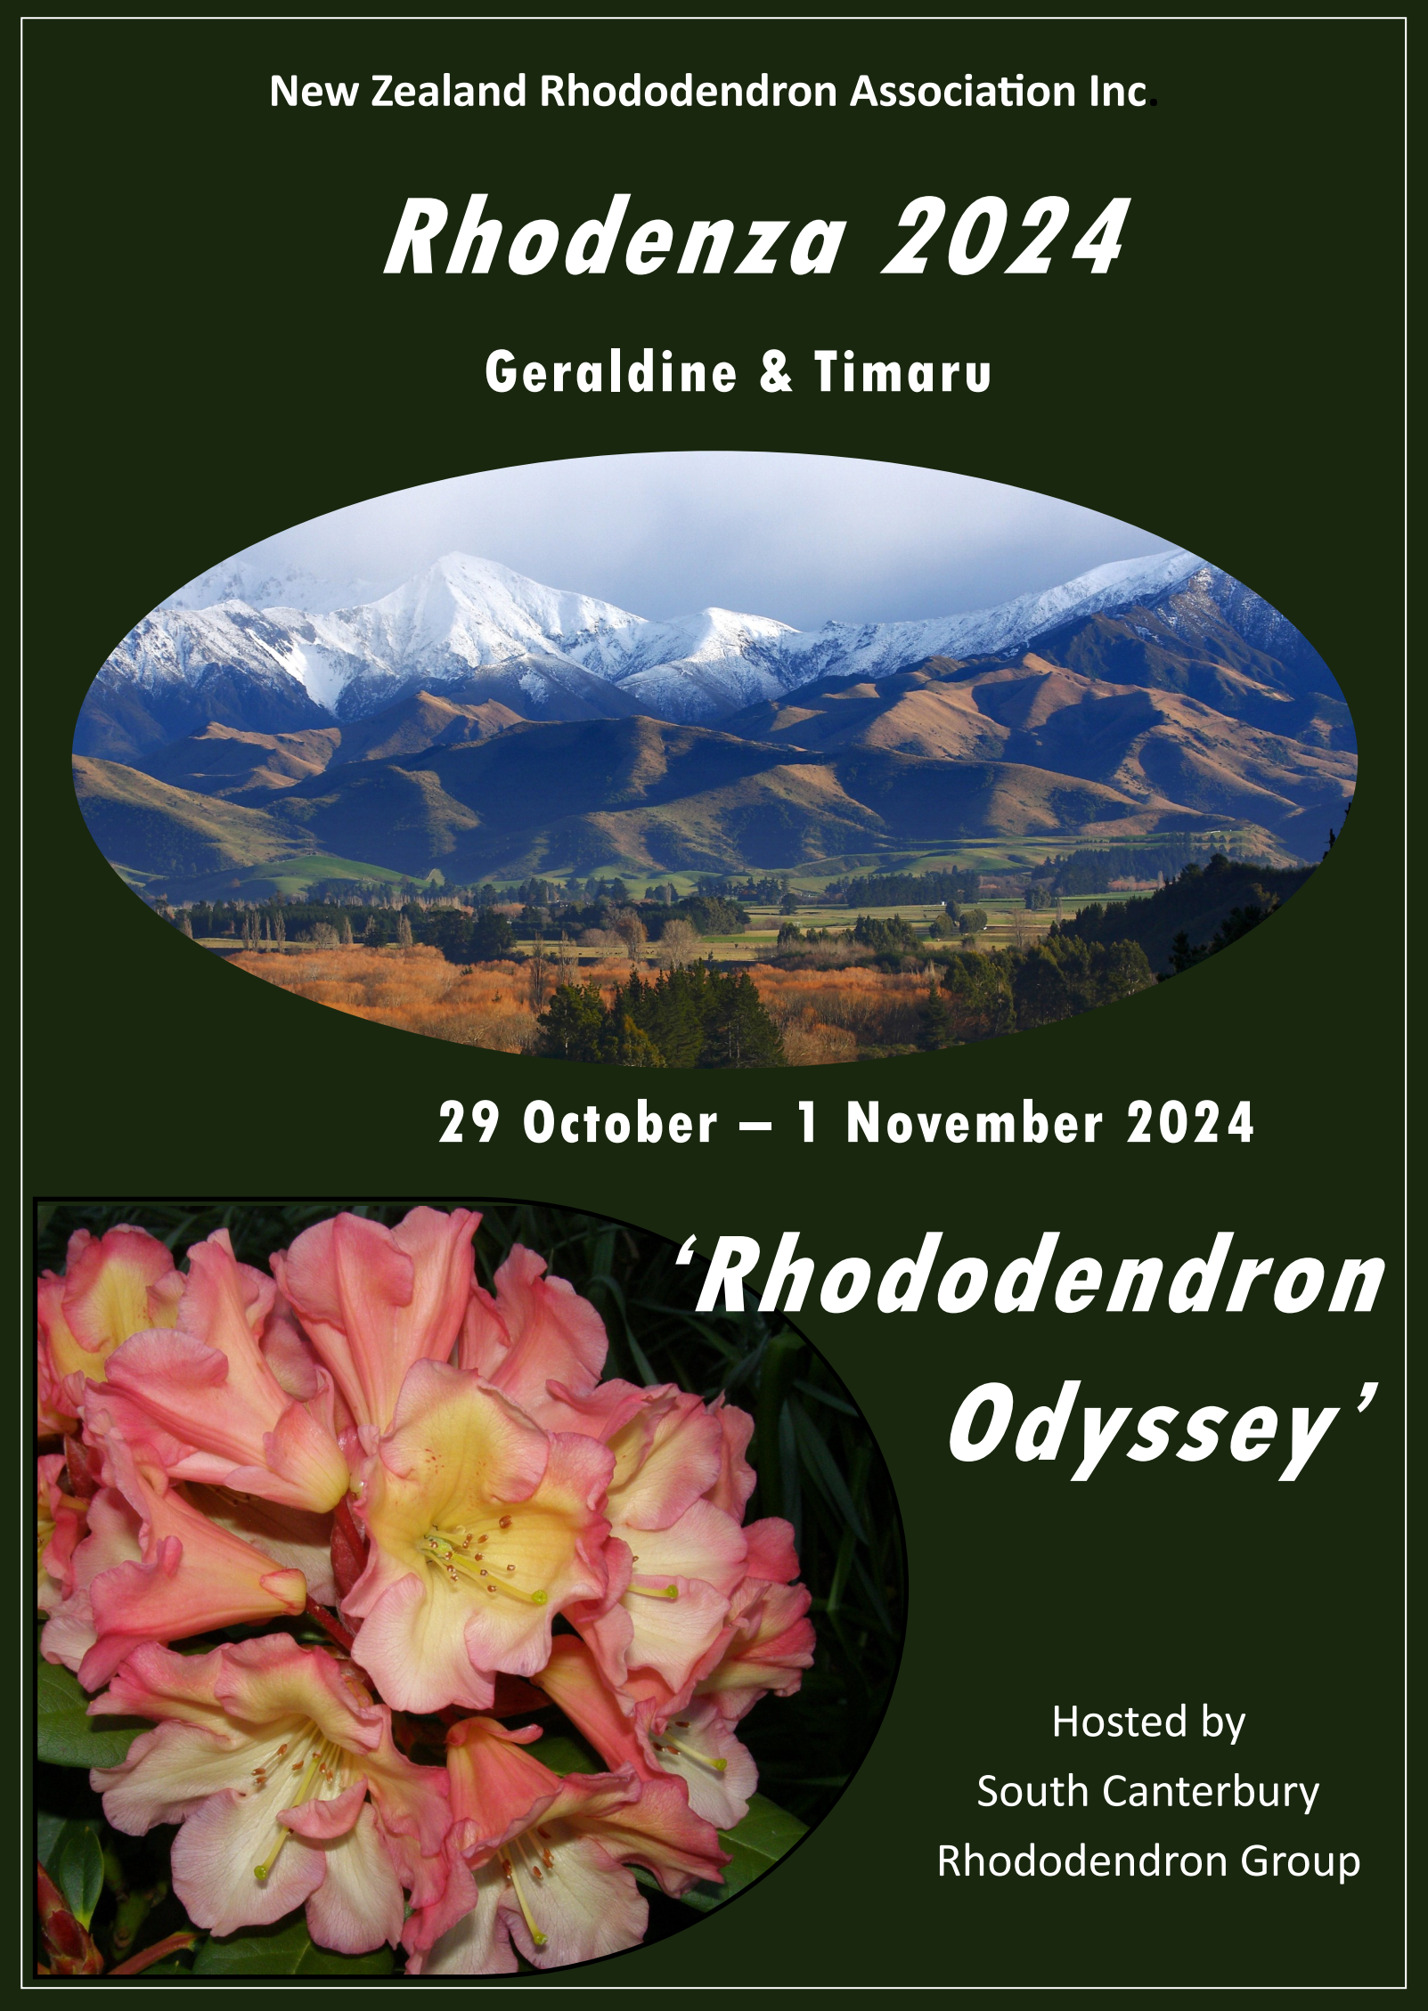
Invitation to Rhodenza 2024,
‘Rhododendron Odyssey’
29th October — 1st November
The South Canterbury Rhododendron Group invite you to join us at the
78th Annual Conference of the New Zealand Rhododendron Association for an action-packed three days of beautiful gardens, amazing scenery, art, food,
and great hospitality
Conference Venue—Woodbury Domain & Hall, Woodbury Road
Bloom Display will be held at Woodbury Domain and we invite you to bring entries for this from 1pm. Vases will be available.
Accommodation To book the following motels you must ring or email and state it is for the NZ Rhododendron conference. You will not be able to book these online as they have been block booked and will appear as no rooms available. Block bookings of the five motels listed will end 16th September so it is strongly recommended you book before this date. Buses will pick up from the first four Motels listed.
Andorra Motel | 03 6938622 | stay@andorramotelgeraldine.co.nz
Four Peaks Motel | 03 6938339 | fourpeaksmotel@xtra.co.nz
Asure Scenic Route Motel | 03 6939700 | stay@motelscenicroute.co.nz
Geraldine Motels | 03 6938501 | info@geraldinemotels.co.nz
Black on Grey Motels | 0800 400070 | info@blackongreymotel.co.nz
Your own transport will be required if staying at Black on Grey Motels as it is 2.5 kms from the town centre and there will be no bus pickup from there. For other accommodation options check out the Geraldine website: visitgeraldine.nz Click on ‘Visit’ tool bar at the top of the page then click on ‘Places to stay’.
Those staying in accommodation away from the town centre of Geraldine must be able to provide their own transport to the pickup points, those being any one of the first four motels listed above. Camping is encouraged in the Hall grounds. Those wishing to bring their caravan/camper van can camp onsite. Booking is not required.
If you are staying on in South Canterbury, we strongly advise that you book accommodation in Timaru for the night of Friday 1st November. This would include those flying out from Timaru , as there is no flight on Friday afternoon.

Free Evening
Wednesday 30th October delegates have a free evening. If you wish to dine out it is advisable to book. The following are all within walking distance of the motels Several takeaway food options are also available.
Village Inn | 03 693 1004 | Jacks Chinese Takeaways | 03 693 7401
Royal India Restaurant | 03 693 8877 | Be Foodie Wilson St | 03 777 2025
Geraldine Fish Supply | 03 693 8441 | Kebab World Talbot St | 03 264 8072
We suggest that you visit the Rhododendron Dell which can be accessed behind the Crown Hotel or the road bridge.
Flight Connections
If there are sufficient numbers, there will be a Ritchies Bus from Christchurch Airport to Geraldine on Tuesday 29th October leaving from outside the domestic terminal at 1.30pm, and returning to Christchurch after the last garden on Friday 1st November arriving at Christchurch airport about 4.30pm. Places for these buses MUST BE BOOKED AND PAID FOR WITH YOUR REGISTRATION. ($100 return per person) Please book your flights accordingly. If your flight leaves Christchurch before 5pm Friday, transport from Timaru is your responsibility
For those flying to Timaru airport, transport to Geraldine can be arranged by the committee if required.
Sale of Rhododendron Prints by Marianna Kneller
For 25 years, Marianna was resident artist at Exbury Gardens, home of the celebrated Rothschild rhododendrons in the UK. There are 6 large coloured prints and 3 smaller pencil studies of various rhododendron species.
Display of Large Leaf Rhododendrons
Ken Jordan will have a display of these and some will be available for purchase.
Weather Conditions
Springtime weather in South Canterbury can be unsettled. You will need clothing suited to both warm and cold and possibly wet conditions. Stout footwear is recommended.
Safety
While every effort has been made to ensure gardens and coach stopping points are safe, it is a condition of registration that you assume responsibility for your own safety and possessions during Rhodenza

Rhodenza Gardens
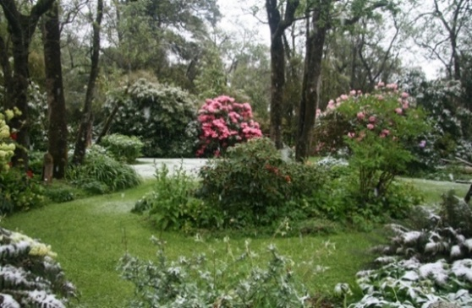
‘Waihi Gorge’, Woodbury Hamilton Family
‘Waihi Gorge’
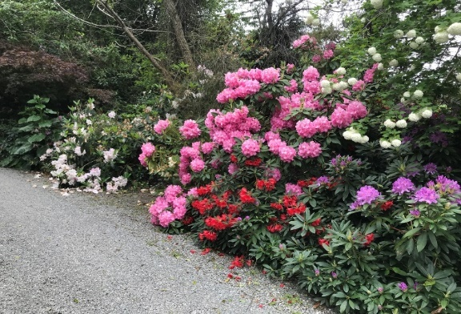
Originally a native logging block then a dairy farm this 13hectare property has been in the family since early 1940’s. The bush has been allowed to regenerate and Michael’s mother (Noel Hamilton) developed a rhododendron garden as an extension to her Timaru garden. Stonewalls were built to keep the sheep out.
Condon Road
Condon Road, Woodbury Gavin Coulter and Jo Marama
Situated 2km west of the Woodbury township on a deer farm this well-established rural garden set amongst Tōtara trees has some 150 rhododendrons from the drive way to the house setting. The tōtara trees are 150 years old and make a great backdrop for this garden.
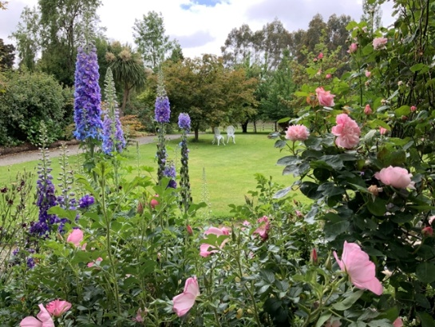
‘The Isle’ Woodbury Ross Harvey and Rosie Woods
‘The Isle’
The first few years after our arrival 17 years ago, were spent removing invasive undergrowth releasing magnolias, rhododendrons and other trees. Perennials have been planted close to the house for perfume and colour. The property was established in 1880 by Ross’s great grandparents, foresters. Fortunately, some of those trees still remain.
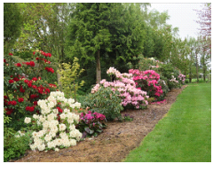
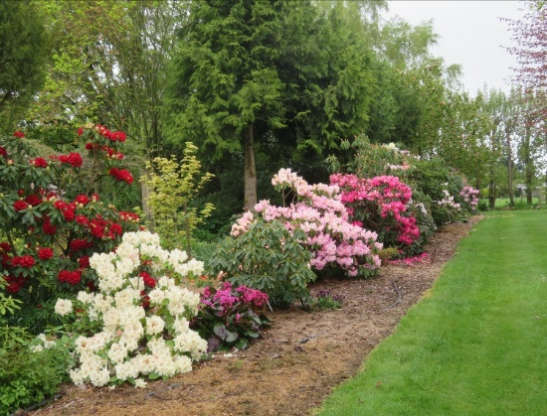
‘Woodbury Rhododendrons’ Bernie and Joy O’Keefe
‘Woodbury Rhododendrons’
‘Woodbury Rhododendrons’
‘Woodbury Rhododendrons’
‘Woodbury Rhododendrons’
‘Woodbury Rhododendrons’
When the 2008 NZRA conference visited our garden it was a’ young’ garden, the rhododendrons are now hugging one another. Plantings of special collections and many of Bernie’s hybrids have been planted since. Most of our rhododendrons are clearly labelled. Our nursery has been scaled right down but there will be some plants available for sale.

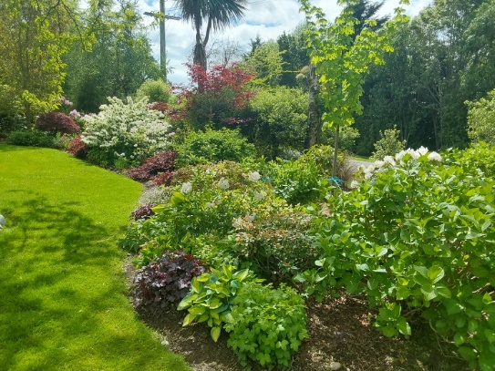
11 Ribbonwood Road, The Downs, Geraldine Ian and Brenda McCulloch
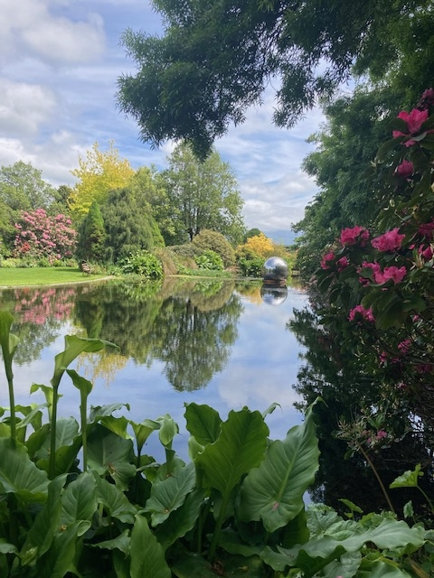
A 3164m vacant section purchased in 2009 required considerable work before a garden could be planted. The soil was clay and drainage was a problem. Years were spent building up the soil with layers of pea-straw. Planting began in 2014 and the house build finished April 2018. The garden has continued to develop while we still work on the soil.
‘Capricorns’ Geraldine Philip and Ros Burdon
Ribbonwood Road
An informal garden of about 3.5 hectares. Deciduous and evergreen trees with NZ natives form the background to an extensive woodland area. Four impressive sculptures, a stainless steel sphere in the large pond reflects the garden around it and three kinetic sculptures move in the wind. A personal garden which has benefitted from the input of two generations.

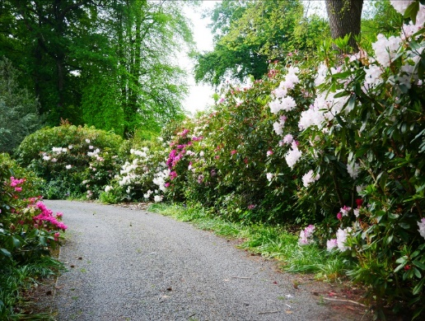
‘Narrambla’ Geraldine Evan and Victoria Thatcher
‘Narrambla’
We arrived 5 years ago to a garden with ivy so thick one lost the chainsaw in it. Cork Elm runners were removed and it was here some of my collection of big leafed rhododendrons from our farm were planted. Several eucryphia, big leafed magnolias, new rhododendrons, arisaemas in pots and trilliums mainly in the dell, add interest to the garden.
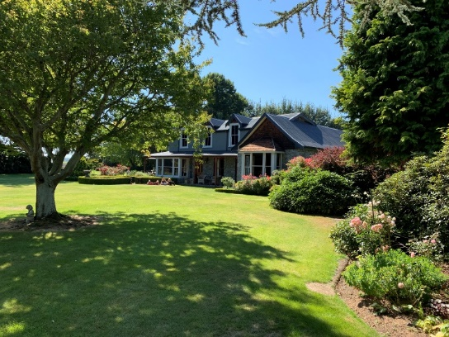
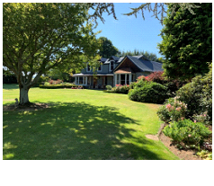
‘Stover' Geraldine Dave and Min Mackenzie
‘Stover’
‘Stover’
In 1974 the ‘Stover’ garden consisted of four trees with narrow borders of annuals. Since then specialist trees, rhododendrons and companion shrubs have been planted. New areas have been opened up enabling the creek to be a feature. Formal brick gardens, stonewalls and several permanent structures add interest and an element of surprise.
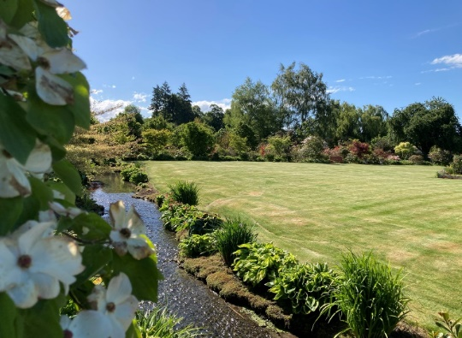
‘The Willows’ Geraldine Warren and Liz Scott
“The Willows”
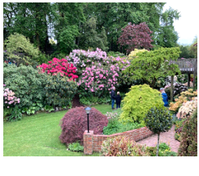
We moved here 9 years ago to a new house which sits on the site of old sheep yards. Prior to the move four years were spent spraying out the weeds. Over the next four winters as many plants as possible were moved from our previous, large farm garden. The stream was an important part of the design of the garden as was retaining the view to Mt Peel.
Branscombe Street, Timaru Alan and Teresa Potter
Since purchasing the property in 1982 we built our home and removed several large trees. The original owner was a keen gardener. Today, two large rhododendrons and the red maple in the rock garden are the only remaining plants from the original garden. In our younger years a gift of six rhododendrons from our parents gave us a start to landscaping and gardening and our love of rhododendrons.

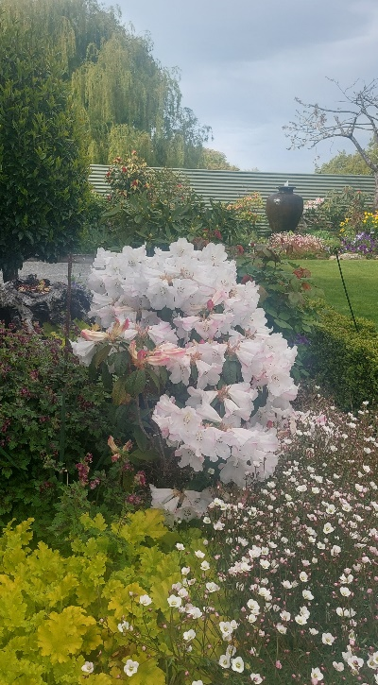
139a Morgans Road, Timaru Mark and Kathryn Beynon
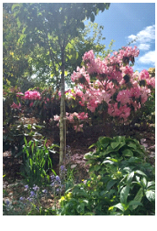
Two existing cherry trees and a rock wall were a good start to the garden, 14 years ago. Initially, natives were planted for privacy but these were gradually replaced with rhododendrons and camellias. Three water features and carefully selected pieces of driftwood add interest to the garden.
139b Morgans Road, Timaru Clare Bryan
A weed covered, steep bank was the first challenge when moving here in 2013. A retaining wall and steps were built. My previous garden of 51 years in Waimate was ¾ acre so I knew what I wanted to grow here. Perfumed plants were planted near the house and flaxes planted at the bottom of the section. All my rhododendrons give me great pleasure every day
139B Morgans Road

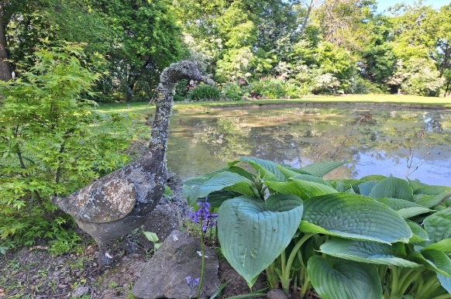
'Oakwood' Timaru Ann Johnstone
The Homestead was built 1904-1906, Bought in 2004, my late husband and I set about opening up the garden around the house leaving two small paddocks for the few sheep brought from the farm. Since my husband's death 6 years ago I have incorporated one of these paddocks into the garden area, put in a wildlife pond and increased the planting. Large trees surround the property (mostly Oaks hence the property name "Oakwood"). These beautiful trees frame the garden and the view up to the mountains.

Programme (may be subject to change)
Tuesday 29 October:
1.00 pm Bloom display set up. Hall set up
3.00 pm Your conference bags will be delivered to your motel. If staying privately, registration will be at the
Woodbury Hall at 5.30pm
5.30 pm Pick ups from pick-up points and travel to Woodbury Hall
6.00 pm Meet and Greet. Drinks
6.30 pm Opening
6.45 pm Buffet Meal
7.45 pm Speaker: Nicky Donkers
8.15 pm Arrangements for Wednesday
9.00 pm Depart for accommodation
Wednesday 30 October:
8.00 am Pick ups from pick-up points
8.30 am NZRA Annual General Meeting at Woodbury Hall
9.00 am Morning Tea
9.30 am Depart for garden visits
9.45 am Arrive Hamilton garden, Waihi Gorge
10.25 am Depart
11.40 am Arrive Coulter garden, Woodbury
11.20 am Depart
11. 35am Arrive Harvey/Woods garden, Woodbury
12.25 pm Depart
12.35 pm Arrive at Woodbury Hall for Lunch
1.05 pm Lisa Williams – talk and demonstration.
2.00 pm Ken Jordan— Large Leaf Rhododendrons
2.30pm Depart.
2.45 pm Arrive O’Keefe garden. Woodbury.
4.00 pm Depart
4.15 pm Arrive Geraldine. Free night
Thursday 31 October
8.00 am Pick ups from pick-up points
8.30 am Arrive Mc Culloch garden. The Downs Geraldine
9.15 am Depart
9.30 am Arrive ‘Capricorns’, Burdon garden. Geraldine/Orari
10.30 am Depart
10.45 am Arrive Thatcher garden. Geraldine. Morning Tea
12.00 am Depart
12.15 pm Arrive MacKenzie garden. Lunch
1.45 pm Depart
2.00 pm Arrive Scott garden. Geraldine.
3.30 pm Depart.
3.40 pm Arrive Geraldine
5.30 pm Pick up from pick up points
6.00 pm Arrive Woodbury Hall. Drinks followed by Dinner. Conference speaker – Geoff Elliott
Friday 1 November:
8.00 am Pick ups, including luggage
8.30 am Depart Geraldine
9.20 am Buses split – one to Potter garden, two to Benyon and Bryan gardens.
10.20 am Depart Buses switch
10.35 am Arrive two to Potter garden, one to Benyon and Bryan garden
11.35 am Depart
Noon Arrive Johnstone garden. Lunch and closing ceremony
1.30 pm Bus departs for Christchurch airport
1.45pm Buses depart for Timaru and Geraldine motel drop-offs
Speakers
Nicky Donkers was born in Geraldine and grew up on a farm on the outskirts of the town. After a period at university studying food and sport science and working away, she returned to Geraldine in 1995 and worked for Bakers Fruit Processors Ltd for 29 years. She is the former Corporate Commercial Director for Barkers. In 2019 Nicky started her own consulting business providing advice to several businesses and not for-profit organisations. She is very involved in several local organisations and supports a strong vision for Geraldine and the surrounding area.
Lisa Williams, along with her husband Stephen, lead RhodoDirect, a vibrant hub for rhododendron enthusiasts. Their journey began in February 2021 when they relocated Rhododirect to Christchurch. Lisa's upcoming talk promises to be a blend of personal experience, transitioning from a gardener's perspective to that of a commercial grower. She'll delve into the nuances of growing rhododendrons, sharing valuable tips on everything from pruning, identifying sun tolerant rhododendrons to pest and disease management. Lisa's passion shines through as she guides fellow gardeners on choosing the perfect rhododendrons for their suburban gardens.

Jeff Elliott: ‘My Journey, 45 Years of Rhodos’
Subject: Propagation hybridization tissue culture and heaps of interesting people
Jeff started working in a nursery called John Thompson in 1980 at 20 years old, he quickly became obsessed with rhododendrons. To Jeff, these appeared the most regal of all plants, they were difficult to propagate and a real challenge. As a runner Jeff often trained at the Ilam fields but had never really taken any notice of the gardens. Well, that all changed, Jeff quickly started a nursery, flogged some cuttings from Ilam, used cold frames and mist propagation. Next was hybridizing, tissue culture, colour laser photo copiers, overseas trips and lots and lots of help and interesting people. The nursery in Amberley covers 35 acres on a 130 acre block that he planned to plant out for larger tree sales, In 2021 Jeff moved away from the nursery and is developing his own garden on a 5 acre block, 3 km from the nursery.
Ken Jordan followed in the footsteps of his father Harold and his grandfather George Clark in one of the oldest family nurseries in New Zealand specializing in growing rhododendrons, camellias, with a strong interest in growing hostas, trilliums, tree peonies and of late, lilies. In 2016 he and his wife purchased Riverstone House in Geraldine and established a small rhododendron nursery. Now in semi-retirement Ken is back doing what he loves best, growing Rhododendrons. Ken has an extraordinarily strong interest in species rhododendrons because they are the ones with the most interesting foliage. He is also making a collection of nuttallii and lindleyi hybrids.
Visitors are welcome.

.

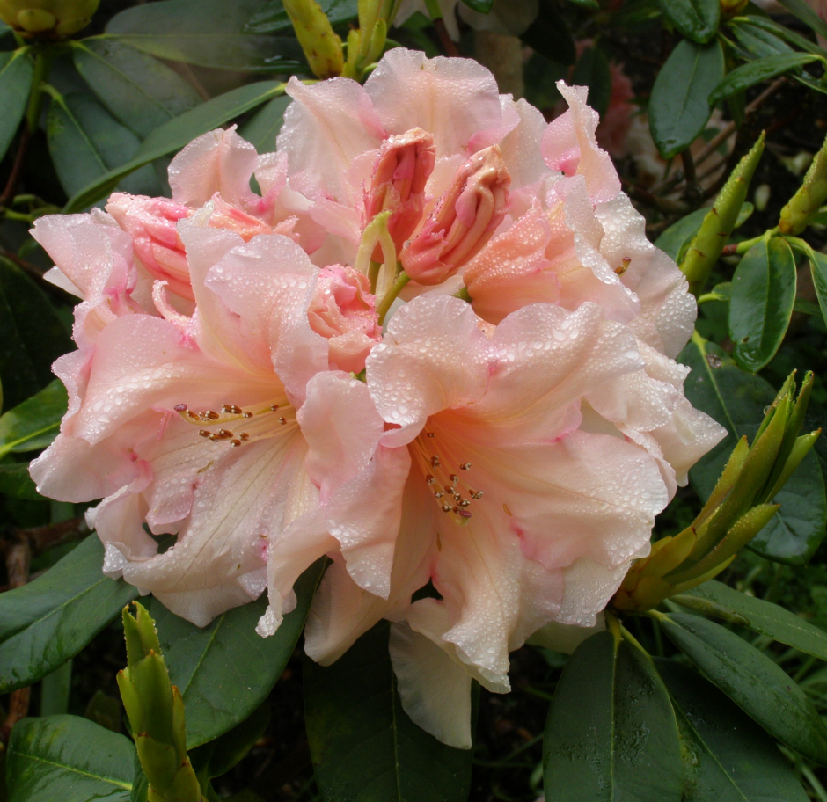
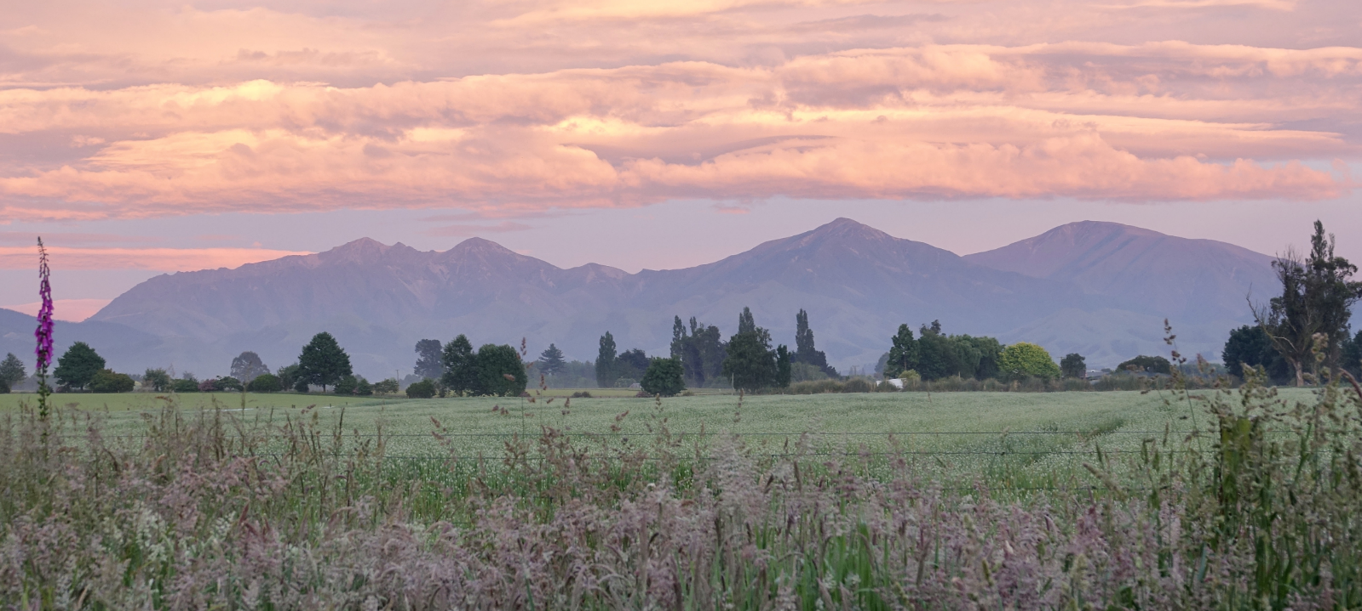


‘Woodbury Rhododendrons’
The Gardens
New Zealand
Rhododendron
Association

